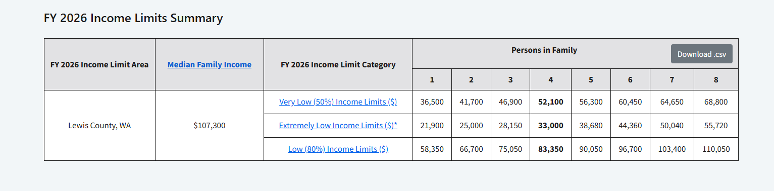
Your income must not be higher than this to qualify for our services
66

